GENERAL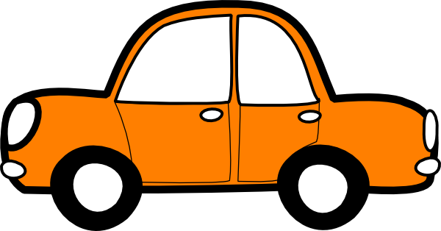
SUMMER CAR KIT

- Water bottles ____
- Snacks ____
- Sunscreen ____
- Paper Towel
- Bug Spray
- Baby Powder
- Wet Wipes
- Hats
- Socks
- Diapers/Change of clothes
- Scissors
- Swiss Army Knife
- Plastic Bags
- Mommy Hook

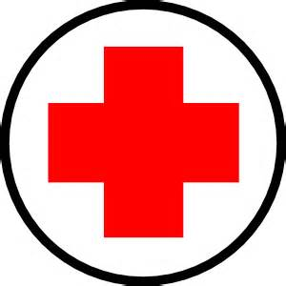EMERGENCY

- First Aid Kit
- Jumper Cables
- Flares
- Flashlight (GB)
- Tire Pressure Gauge (GB)
- Quarters (GB)
- Road Reflectors
- Red/White Rags

